SIS 325: Development and Planning
Spring 2021
Dr. Mason Kim

Research Paper

Title Here (Font size 14)

Your Name Here

Abstract

Write one paragraph (about 200 words) of abstract here.

I. Introduction

Introduction (about one page) should include the following information: (a) topic/ motivation/ importance of the research project (i.e., why are you interested in this topic? Why is it important?), (b) research question (i.e., what question(s) are you going to address?), (c) a brief answer to the question (i.e., your arguments and/or findings), and (d) the structure of the research paper (e.g., “In the next section, this paper will describe how X, Y, and Z occurred….” “The following section will explore key driving factors behind the issue….” “The conclusion will summarize the main arguments/findings and then provide some policy proposals for…”).

II. Issue Description ( Make your own title of this issue-description section.)

A. Subtitle

This section (about 3 pages) is to fully describe the issue/problem of your choice. Be as specific as possible in providing any relevant information regarding the issue (i.e., what happened, when and where it happened, who are responsible for and/or victimized, and how it is growing as an important global issue, etc.). Maps, statistics, cases, and any useful sources of information can be used. When you provide the information, don’t forget the use of in-text citations (http://libraryguides.bennett.edu/home/writing/chicago-turabian-style/turabian-style-in-text-parenthetical-citations--reference-list).

Example of Table
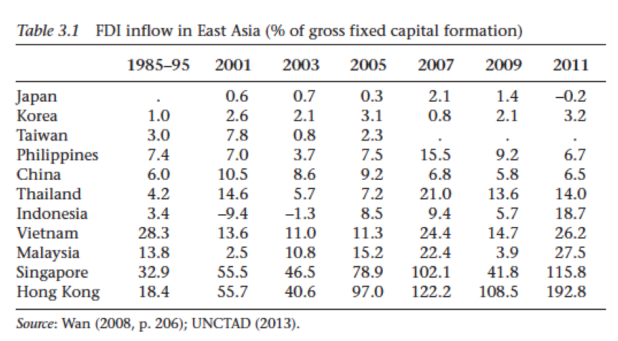

Example of Figure
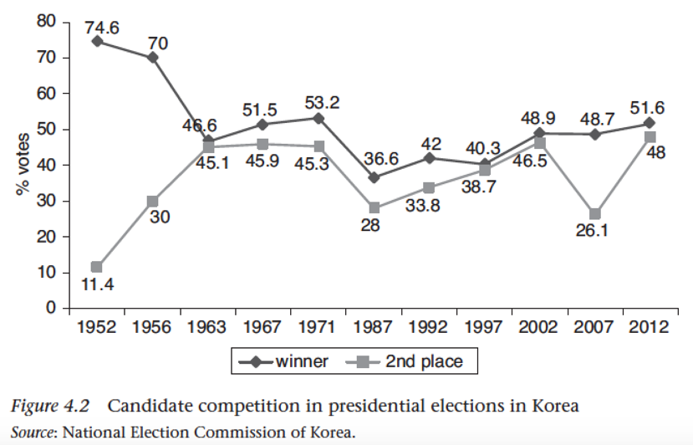
III. Issue Analysis ( Make your own title of this issue-analysis section.)

This section (about 4 pages) is to analyze the issue of your choice, thus addressing the question of “why?” (e.g., why are anti-Muslim sentiments growing so rapidly in France? Why is foreign aid less effective in helping poor countries getting out of the poverty trap? Why has Boko Haram changed from a sociocultural organization to a regional terrorist group?) You have already described the problem in the previous section, and therefore, the next logical task is to answer the question of why. Examine any political, economic, social, cultural, geographic, or historical factors that you believe have caused the problem.

In this section, you MUST use a causal diagram at the beginning to illustrate the cause-effect relationship of the issue. Literature review will help you establish a causal mechanism of your theory. Your explanations should be logical, consistent, and empirically supported. Also, don’t forget the use of in-text citations.

Examples of Causal Diagram

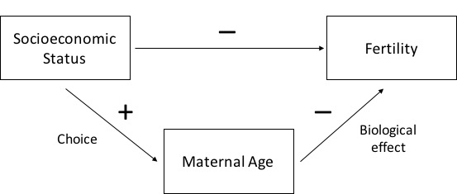

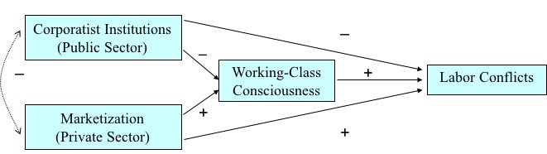
IV. Conclusion

In this section (about 1 or 2 pages), you are expected to briefly recap the issue, question, and your explanation and findings. This section is the place where you can re-highlight the importance of your research and provide policy suggestions if any.

Bibliography

When you collect information and data, refer to academic works such as journal articles and book chapters as primary sources. Web resources can be used, but you should check on the credentials. Below is the information of the APA style of bibliography (or references).

- Basic Rules https://owl.purdue.edu/owl/research_and_citation/apa_style/apa_formatting_and_style_guide/general_format.html

